# General Notes:

* The morning group made a mix-up and tested our port wing, so we tested the starboard wing
* We need use the port wing data collected by the morning group to write the report
* Brano will email us the data and the analysis code

# Set-up (starboard wing):

* 7 out of plane tapping points (L1 L2 L3 L4 T1 T2 T3)
  + ,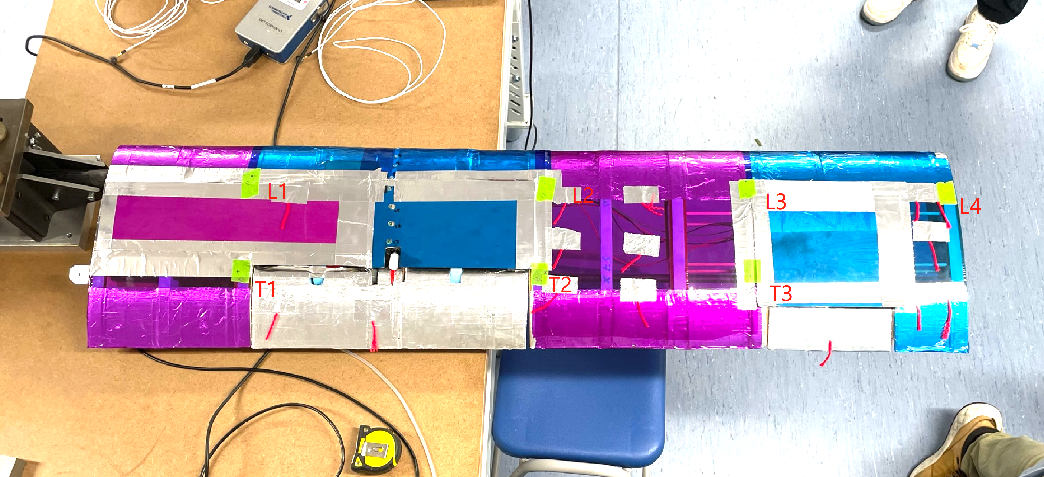
* 3 in-plane tapping points (in-line with L1 L2 L4)
  + 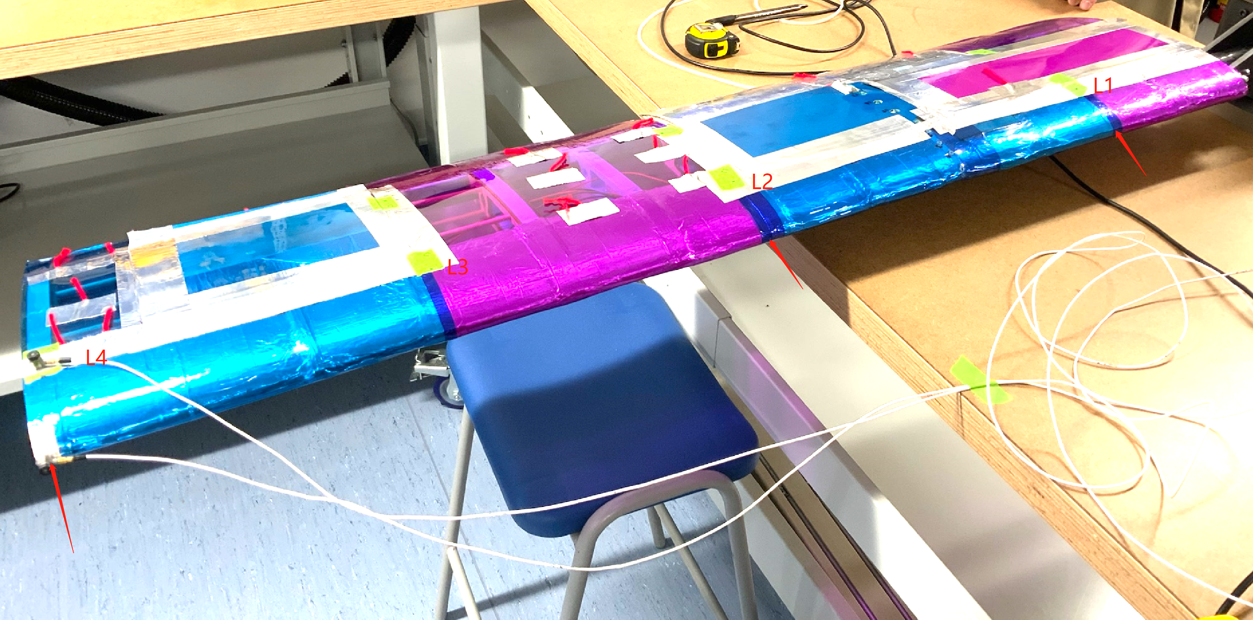
* 2 accelerometers, one in x direction, one in z direction
* 3 taps on each taping point, and the 3 FRFs are averaged

Tapping point locations:

|  |  |  |  |
| --- | --- | --- | --- |
| Y-axis | (mm) | X-axis | (mm) |
| L1 | 200 |  |  |
| L2 | 615 | L3-T3 | 144 |
| L3 | 905 |  |  |
| L4 | 905+280 | T2-L2 | 137 |
| T1 | 195 |  |  |
| T2 | 608 | L1-T1 | 145 |
| T3 | 903 | Avg X | 142 |

Note: Average X is used, y-axis datum is wing root, need to add the distance from wing root to the bolt when modelling

* More photos and videos available in CompanyA/General/Photo Dump

# Set-up (port wing):

* 6 out of plane tapping points, (3 in-plane?, TBC)